

AERONAUTICAL PRINCIPLES

Semester 2
Student Name: Arpan K Roy
Module: Aerospace Engineering Principles (TRANS43004)
Submission Date: 05/05/2026
Word Count: 4607
Contents
Part A – Career Reflection 3
Part B – Aircraft System Technical Report 4
Topic: B737 Max – MCAS (anti-stall / pitch-up) system 4
1. Introduction 4
2. Background: Need for MCAS 5
3. Components of the MCAS System 6
4. Working of MCAS 6
5. Pilot Interaction with MCAS 7
6. Design Issues and Improvements 7
Part C – Investigation of Design-Related Air Crash 9
Investigation of Lion Air Flight 610 crash and Ethiopian Airlines Flight 302 crash 9
1. Introduction 9
2. Aircraft Background and Design History 9
3. FDR-Based Sequence Analysis 9
4. Technical Cause Analysis 11
5. Human Factors Analysis 13
6. Allotment of Blame 14
7. Design Errors (Root Causes from Development Phase) 14
8. Recommendations 14
9. Conclusion 15
References 16

Figures
Figure 1. Difference between B737 MAX CFM LEAP-1B & B737NG CFM56-7B engines (Hamilton, 2019) 4
Figure 2. Mechanism of B737 MAX MCAS (Schuurman, 2020) 5
Figure 3. AoA sensor - B737 MAX (Bellamy III, 2020) 6
Figure 4. Stabiliser trim switches of B737 MAX (DEV Community, 2019) 7
Figure 5. Flight path of Lion Air Flight 610 (BBC, 2019) 10
Figure 6. Flight path of Ethiopian Airlines Flight 302 (BBC, 2019) 11
Figure 7. AND Gate (GeeksforGeeks, 2024) 12

Part A – Career Reflection
My main career goal is to become an aircraft maintenance engineer, with the long-term aim of progressing into higher engineering roles within the aircraft industry. After completing my BEng (Hons) Aeronautical Engineering degree from Staffordshire University, I intend to work as an aircraft mechanic or licensed engineer, focused on aircraft safety, reliability, and airworthiness through inspection, repair, and maintenance operations. I also plan to either pursue a Master’s degree to deepen my technical knowledge or follow the Part-66 B1 licence pathway to become a fully qualified aircraft maintenance engineer.
Through my Aeronautical Engineering course, I have developed a strong foundation in aerodynamics, thermofluids, mechanics, and basic aircraft systems. I have also gained experience in CAD software such as Autodesk Inventor and CATIA. This technical knowledge is supported by transferable skills, including communication, teamwork, and time management.
My roles as a Student Ambassador have significantly improved my confidence, communication skills, and ability to work efficiently in high-pressure environments. Delivering campus tours and interacting with diverse groups has strengthened my professionalism, while also preparing me to work effectively within maintenance teams. Additionally, being multilingual further enhances my ability to operate in the global aviation industry.
However, I need to develop more hands-on mechanical experience and practical exposure to real aircraft systems. To address this, I plan to secure internships or placement opportunities, particularly within maintenance, repair, and overhaul (MRO) organisations. I also plan to engage in engineering societies, attend workshops and career fairs, and pursue additional training to improve my understanding of aviation rules & regulations, such as EASA Part-66 requirements, and continue developing my technical and professional skills.
By building on my strengths and addressing these areas for development, I aim to become a competent, competitive and professional aircraft maintenance engineer.

Part B – Aircraft System Technical Report

Topic: B737 Max – MCAS (anti-stall / pitch-up) system
MCAS (Maneuvering Characteristics Augmentation System)

Introduction
MCAS, or Maneuvering Characteristics Augmentation System, is a flight control law installed on the Boeing 737 MAX to improve the aircraft's handling characteristics during specific flight conditions and automatically adjust the aircraft’s horizontal stabiliser to counteract the aerodynamic pitch-up (caused by scientific laws) tendency that occurs at high Angles of Attack (AoA). By commanding nose-down stabiliser trim, the MCAS helps maintain stable aircraft behaviour and assists the aircraft in preventing stalling conditions (SKYbrary, 2024).
From a control systems perspective, MCAS operates as a feedback-based augmentation system intended to alter the longitudinal stability of the aircraft without the need for pilots.
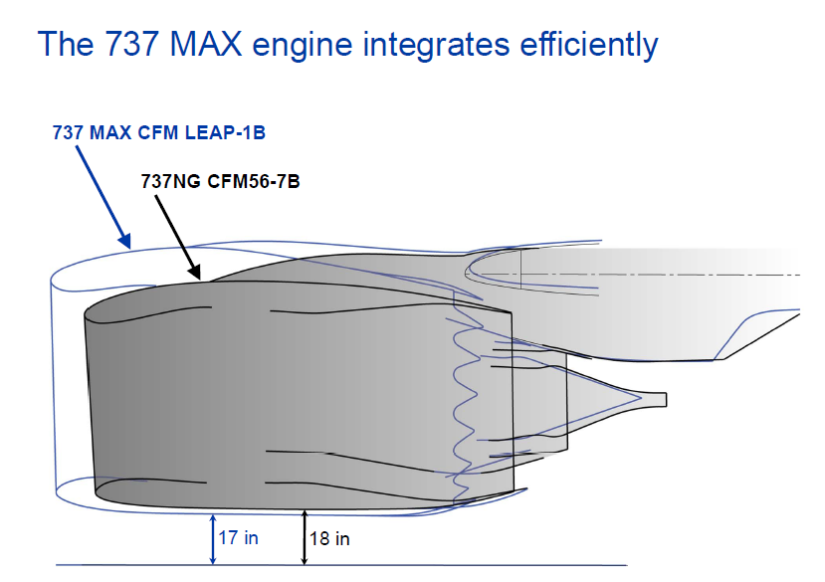
The Boeing 737 MAX introduced larger and more fuel-efficient engines compared to previous models of the aircraft. These engines, CFM LEAP-1B, were positioned slightly forward and higher on the wing to ensure enough ground clearance as compared to Boeing 737NG CFM56-7 (refer to Figure 1).
However, this modification led to a change in the aerodynamic characteristics of the aircraft. At higher AoA, the aircraft had a
Figure 1. Difference between B737 MAX CFM LEAP-1B & B737NG CFM56-7B engines (Hamilton, 2019)
tendency of experiencing a stronger pitch-up moment than previous versions of the Boeing 737 (SKYbrary, 2024).
To address this issue, Boeing introduced the MCAS as a software-based augmentation system integrated into the Flight Control Computers (FCC). This system activates automatically during specific flight conditions without any pilot input and commands nose-down stabiliser movement to maintain stable pitch characteristics (The Air Current, 2018).
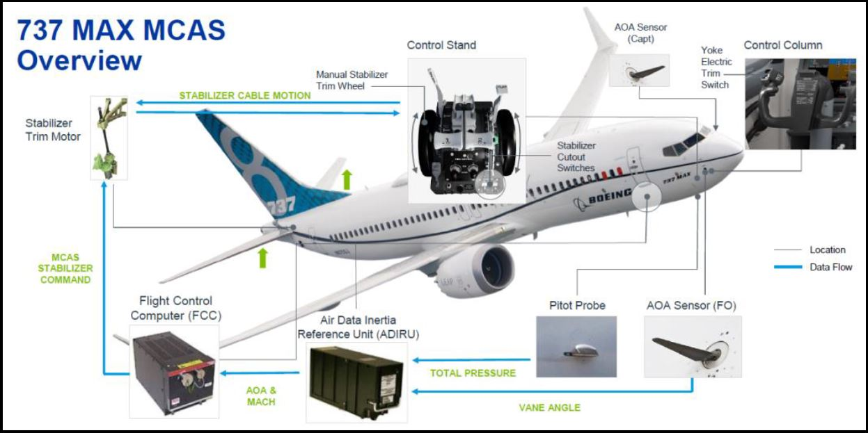
The goal was to ensure that the Boeing 737 MAX maintained its similar handling characteristics to the earlier 737 models while complying with the aircraft certification regulations.
Figure 2. Mechanism of B737 MAX MCAS (Schuurman, 2020)

Background: Need for MCAS
The B737 MAX was developed as an upgraded version of the previous 737 with improved fuel efficiency of up to 15% and lower operating costs. One of the major changes in the design was the introduction of a larger CFM LEAP-1B turbofan engine. These engines have a larger fan diameter than the engines used on previous 737 models (Simple Flying, 2025).
Due to the relatively low ground clearance of the 737 airframe, the larger engines could not be mounted in the same position as the earlier engines. Instead, they had to be installed further forward and slightly higher on the wing. This change altered the airflow around the aircraft and affected its aerodynamic properties (SKYbrary, 2024 & Simple Flying, 2025).
At higher AoA, the engine nacelles generate additional lift forward of the Centre of Gravity (CG), which can create a pitching moment that pushes the aircraft’s nose upward.
Because this force is applied at a distance (d) from the CG, it creates a pitching moment (M) according to the moment principle:
$$M= F_{nacelle}×d$$
Since the nacelles are located forward of the aircraft’s centre of gravity, this lift produces a pitch-up effect that reduces the force required for the pilot to pull the control column back. This could potentially lead the aircraft to a stall condition easily (B737 MAX MCAS, 2018).
To address this aerodynamic issue, Boeing introduced the MCAS so that it automatically applies nose-down stabiliser trim when the aircraft approaches its high AoA. This helps maintain predictable handling characteristics and complies with aircraft certification regulations related to stall behaviour of aircraft (SKYbrary, 2024).

Components of the MCAS System
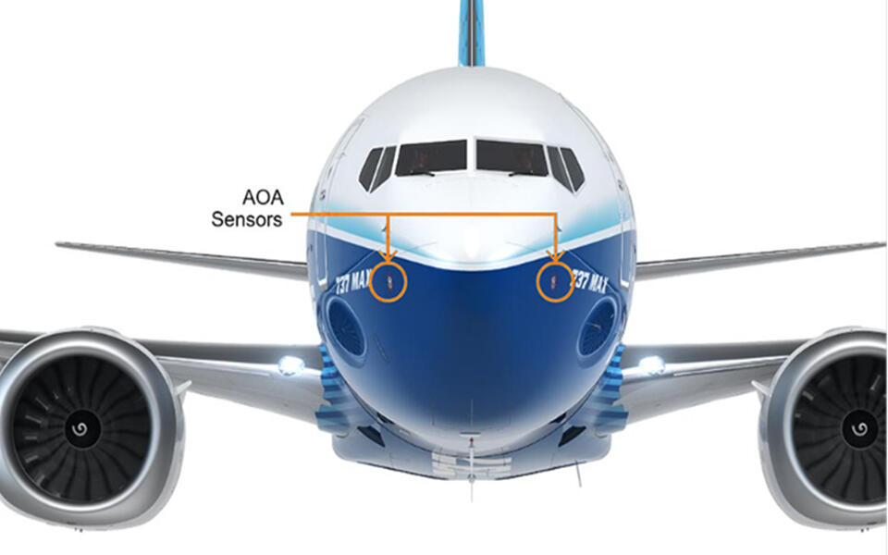
MCAS is a software function integrated into the aircraft’s flight control system. The system operates using inputs from sensors and aircraft computers to determine when stabiliser trim adjustments are required.
One of the most important inputs for MCAS is the AoA sensor (refer to Figure 3).
The angle of attack refers to the angle between the aircraft wing and the direction of airflow. These sensors continuously measure the aircraft’s aerodynamic condition and send data to the Flight Control Computers (FCC).
The Flight Control Computer processes data from the AoA sensors along with other flight parameters such as airspeed and altitude. The MCAS software logic within the FCC evaluates this information to determine whether the aircraft is approaching a high angle of attack condition that requires an automatic stabiliser trim adjustment (B373 MAX MCAS, 2018).
Figure 3. AoA sensor - B737 MAX (Bellamy III, 2020)
Another key component involved in the MCAS system is the stabiliser trim system. The horizontal stabiliser, which is located at the tail of the aircraft, can be adjusted to control the aircraft's pitch attitude. When MCAS activates, it commands the stabiliser trim motor to move the stabiliser in the nose-down direction. This stabiliser movement generates a pitching moment that lowers the aircraft's nose and reduces the angle of attack (The Air Current, 2018).
Other components that interact with the MCAS include the air data system and flight control sensors, which provide additional information needed for the MCAS logic to determine whether activation conditions have been met (B737 MAX MCAS, 2018).

Working of MCAS
The MCAS system works automatically when specific flight conditions are detected. The system functions during manual flight, only meaning when the autopilot is disengaged, and the aircraft's flaps are fully retracted. Under these conditions, the Flight Control Computer continuously monitors the aircraft's angle of attack using AoA sensors (B737 MAX MCAS, 2018).
If the system detects that the aircraft's angle of attack surpasses a pre-set limit, MCAS activates and commands the stabiliser trim system to move the horizontal stabiliser in the nose-down direction. These stabiliser movements produce a pitching moment that reduces the aircraft’s angle of attack and prevents the aircraft from a stall condition (B737 MAX MCAS, 2018).
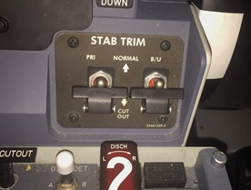
In the original design of the MCAS system, the MCAS relied on input from a single AoA sensor connected to the flight control computer. When the system could command stabiliser movement at a rate of approximately 0.27 degrees per second for about 9 seconds, producing a total stabiliser change of up to around 2.5 degrees nose-down (B737 MAX MCAS, 2018).
If the high-angle-of-attack condition remained present after the initial activation, MCAS could reset and activate again after a short pause, applying additional nose-down stabiliser trim. Electric trim switches located on the control column could be used by pilots to interrupt the stabiliser movement, or pilots could disable the stabiliser trim system (as shown in Figure 2) using the stabiliser cut-out switches in the cockpit (The Air Current, 2018).
Figure 4. Stabiliser trim switches of B737 MAX (DEV Community, 2019)

Pilot Interaction with MCAS
MCAS was mainly designed to operate automatically in the background without any input from the pilot. The system activates the MCAS only under specific flight conditions and does not have a dedicated control panel in the cockpit. As a result, pilots usually interact with the aircraft’s pitch control system through the control column and stabiliser trim switches rather than directly with the MCAS.
When the MCAS commands nose-down stabiliser trim, pilots may observe changes in the aircraft's pitch behaviour. If unwanted stabiliser trim occurs, pilots can counteract it by using the electric trim switches on the control column, allowing manual control of the stabiliser trim motor (B737 MAX MCAS, 2018).
The aircraft is also equipped with stabiliser cut-out switches located on the centre pedestal. In case of an abnormal trim behaviour, cut-out switches allow pilots to disable the electric stabiliser trim system (The Air Current, 2018).

Design Issues and Improvements
Although MCAS was originally intended to improve aircraft handling and safety, several design issues came to light following investigations into the B737 MAX accidents. One of the most significant problems was that the system relied on input from only a single AoA sensor during each flight. If that one sensor provided incorrect data due to damage or malfunction, the flight control computer could incorrectly interpret the aircraft as being in a high angle of attack condition (B737 MAX MCAS, 2018).
In such a situation, MCAS could repeatedly command nose-down stabiliser even though the aircraft was not actually approaching a stall condition. This could cause the aircraft to pitch downward when not expected and increase workload on the pilots as they would try to counteract the stabiliser movements (The Seattle Times, 2019).
Another issue identified during the investigation was that many pilots were unaware of the MCAS system or its purpose during abnormal situations because it had not been extensively described in early pilot training materials (The Air Current, 2018).
Following the investigations, several improvements were introduced to the MCAS system. The updated design now compares input data from both AoA sensors instead of relying on a single AoA sensor. If two sensors provide different readings, the system would simply not activate. The amount of stabiliser movement that MCAS can command has also been limited, ensuring that pilots can maintain control of the aircraft using the elevator alone (B737 MAX MCAS, 2018).
A modification to the activation and resynchronisation schedule was also made for high-angle-of-attack situations. In the updated system, MCAS was restricted to operating only once during a single high AoA event instead of activating repeatedly. In its original configuration, the system could run for approximately 10 seconds, pause for about 5 seconds, and then activate again if it continued to detect a high angle of attack condition. The updated system improved the logic controlling stabiliser trim after pilot intervention. If pilots use the electric trim switches or use the control wheel to apply sufficient forward input to stop the MCAS command, the system now effectively restores the stabiliser to the correct trim position. This improvement ensures that the aircraft returns to a stable trim state after pilot actions. (B737 MAX MCAS, 2018).
Additional pilot training requirements and software updates were also implemented as a part of the recertification process before the B737 MAX was brought back to commercial service (B737 MAX MCAS, 2018).

Part C – Investigation of Design-Related Air Crash

Investigation of Lion Air Flight 610 crash and Ethiopian Airlines Flight 302 crash

Introduction
The crashes of Lion Air Flight 610 (2018) and Ethiopian Airlines Flight 302 (2019) involved the B737 MAX aircraft and resulted in 346 fatalities. These accidents were widely regarded as design-related failures involving the Maneuvering Characteristics Augmentation System (MCAS), a flight control system introduced to compensate for aerodynamic changes in the aircraft.
The report consists of a sequence of events using available investigation data, flight behaviour consistent with FDR (Flight Data Recorder) analysis, and examines the engineering, human, and organisational causes. The report also evaluates design failures, assigns responsibility, and proposes recommendations to prevent recurrence.

Aircraft Background and Design History
The B737 MAX was developed as an upgrade to the Boeing 737 next-generation series, mainly to improve fuel efficiency with larger, more efficient engines. Due to ground clearance limitations, these engines were mounted further forward and higher on the wing.
This modification led to nose-up tendency, as it altered the aircraft's pitching moment characteristics at high angles of attack. This introduced a risk of reduced longitudinal stability and non-linear control force behaviour near stall conditions.
To compensate, Boeing invented the MCAS system, which automatically commands nose-down stabiliser trim when a high angle of attack is detected (Flightradar24, 2020). The system was designed to rely on a single AoA sensor input, introducing a critical single-point failure (Bureau of Aircraft Accidents Archives).

FDR-Based Sequence Analysis

3.1 Lion Air Flight 610
  - Take off phase: Aircraft departs from Soekarno-Hatta International Airport in Jakarta at 6:21 am local time
  - +2 minutes: Left AoA sensor begins transmitting high values (20$°$ higher than actual) (Wisner Baum, 2018)
  - MCAS activation: System interprets this as an impending stall and commands nose-down stabiliser trim
  - Pilot response: Pilot Crew applies back pressure and electric trim to counteract
  - System behaviour: MCAS resets and reactivates every few seconds, creating a loop
FDR data indicated repeated stabiliser trim movements in the nose-down direction, with each activation increasing trim displacement. At the same time, the airspeed recorded showed a continuous increase, which further amplified aerodynamic loads on the control surfaces
  - Pilot trims nose-up $→$ MCAS trims nose down again
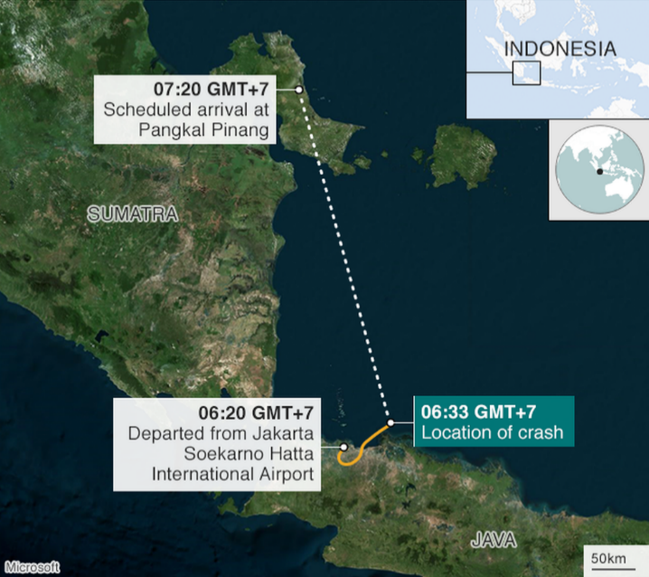
CVR recordings suggest increasing confusion and urgency in the cockpit, as the pilots attempt to counteract the repeated trim inputs without understanding the main cause.
Flight progression:
  - Increasing control forces required
  - Airspeed increases, leading to an increase in aerodynamic loads
  - The stabiliser moves progressively nose-down
Final phase:
  - The aircraft entered a steep dive and plunged into the Java Sea after 11 minutes of push and pull between the MCAS and the two pilots (EthiopianFlight302.com)
Figure 5. Flight path of Lion Air Flight 610 (BBC, 2019)

3.2 Ethiopian Airlines Flight 302
  - Take off phase: Aircraft departs from Bole International Airport, Addis Ababa, at 8:38 local time
  - Immediately after take-off, the AoA sensor failure provides incorrect data
  - MCAS activation: Repeated nose-down trim commands begin (Flightradar24, 2020)
Pilot response:
  - Attempt trim correction
  - Follow the runaway stabiliser checklist
  - Disabled electric trim
(Critical Issue: At high speed, the manual trim becomes physically difficult to control due to high aerodynamic loads on the stabiliser)
Final phase:
  - The aircraft disappeared from radar screens and crashed 6 minutes after taking off
FDR data from the flight indicated fluctuations in vertical speed and stabiliser position, consistent with repeated MCAS activation.
CVR recordings captured the pilots attempting to follow emergency procedures while having trouble controlling the aircraft due to increasing control forces.
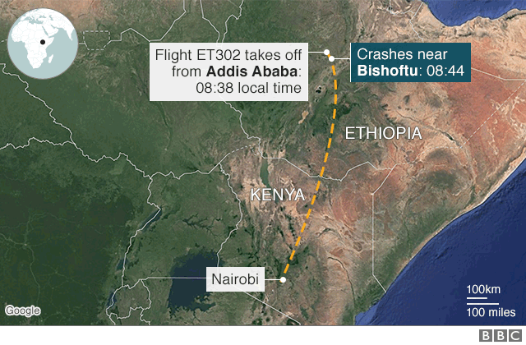
Figure 6. Flight path of Ethiopian Airlines Flight 302 (BBC, 2019)

Technical Cause Analysis
  - Aerodynamic Instability
The repositioning of the larger engines on the B737 MAX altered the aircraft's aerodynamic characteristics, particularly at high angles of attack. The engines generated additional lift ahead of the centre of gravity, creating a nose-up pitching moment. This reduced longitudinal stability and increased the risk of an aerodynamic stall.
To compensate for this behaviour, MCAS was introduced to automatically apply nose-down stabiliser trim to effectively counteract the pitch-up tendency and restore handling characteristics like those of earlier 737 models (Flightradar24, 2020).
As demonstrated in Part B, the increased d (distance) of the LEAP-1B engines directly resulted in the unstable pitching moment M that MCAS was designed to mask.
  - Faulty Sensor Input
Both accidents were initiated by incorrect AoA sensor data that falsely indicated the aircraft was approaching a stall condition (Bureau of Aircraft Accidents Archives).
Since MCAS relied on input from a single AoA sensor, it could not verify the data. As a result, the MCAS system was activated unnecessarily, despite the aircraft being in normal flight conditions (The Independent, 2019).
  - Control System Behaviour
According to the control systems perspective, MCAS functioned as a feedback controller designed to stabilise the aircraft during high AoA conditions. However, the system lacked several critical features:
  - Redundancy: It depended on a single sensor input
  - Input validation: No comparison between multiple sensors
  - Rate limiting: No effective restriction on repeated activation
Lack of these resulted in an unstable control loop, where each MCAS activation moved the aircraft further away from a stable condition. Instead of correcting the aircraft's behaviour, the system amplified the problem (EthiopianFlight302.com).
  - Progressive Trim Saturation
Repeated MCAS activations caused incremental stabiliser movement, progressively increasing the nose-down trim position.
This led to:
  - Increasing control forces by the pilots
  - Reduction of the effectiveness of the elevator
Eventually, the stabiliser reached a point where:
- The elevator authority was insufficient to counteract the nose-down movement
- Pilots could no longer control the aircraft
This condition, known as trim saturation, directly contributed to the loss of control of the aircraft (EthiopianFlight302.com).
  - Failure Classification and Analysis
The incident can be classified as a system-induced loss of control, triggered by incorrect sensor input and automated flight control responses. According to a systems engineering perspective, this represents a feedback loop failure, where incorrect input data resulted in repeated corrective outputs that progressively destabilised the aircraft. The absence of redundancy and validation mechanisms further classifies this as a failure within a safety-critical system, highlighting deficiencies in both system architecture and failure mode analysis.
  - Fault Tree Analysis (FTA)
A simplified fault tree analysis of the accident identifies the top event as loss of aircraft control. The primary contributing factors include incorrect AoA sensor input data, MCAS activation logic, and pilot response limitations. The AND gate (Sensor A AND Sensor B) required for safety was missing as well.
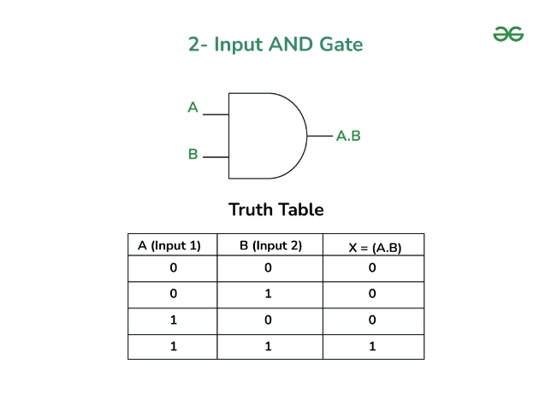
Figure 7. AND Gate (GeeksforGeeks, 2024)

Hence, the absence of redundancy and validation mechanisms allowed a single point failure to propagate through the whole system of aircraft, ultimately leading to an aircraft incident.

Human Factors Analysis
  - Cognitive Overload
During both incidents, pilots were exposed to multiple and continuous warnings, including stick shaker activation, airspeed disagreements, and altitude alerts.
These conflicting signals significantly increased the workload, reducing the pilot’s ability to correctly diagnose the situation and respond effectively (BBC News, 2021).
Additionally, reports based on cockpit voice recordings indicate a high level of urgency and confusion experienced in the cockpit, with pilots reacting under extreme stress during the final moments of the flight (Daily Mirror, 2024). This further highlights the psychological pressure faced by the crew during the incident.
  - Lack of System Awareness
The MCAS guide was not clearly provided in pilot training manuals or operational documentation. As a result, pilots were unaware of its existence and behaviour.
This meant that during the emergency, pilots were attempting to resolve a problem caused by a system they did not understand, leading to ineffective responses (The Independent, 2019).
  - Training Deficiencies
Pilots transitioning to the B737 MAX did not receive simulator training specific to MCAS. Additionally, there were no clear procedures for repeated automatic stabiliser trim inputs.
This lack of training prevented the pilot from recognising the failure and applying the correct recovery actions on time.
  - Maintenance Contribution (Lion Air)
In the case of Lion Air Flight 610, a faulty AoA sensor had been installed before the flight. The same issue had been reported on previous flights but was not adequately resolved. This indicated deficiencies in maintenance procedures and quality control (Wisner Baum, 2018).
  - Human-Machine Interface Failure
The MCAS system demonstrated poor integration between human operators and automated systems. Key issues included:
- Lack of transparency: Pilots were not informed about the MCAS activation
- Poor feedback: No clear indication of the cause of trim movement
- Automation override: The system repeatedly counteracted pilot inputs
These factors contributed to the confusion and reduced the pilot’s ability to maintain control (EthiopianFlight302.com).

Allotment of Blame
  - Primary Responsibility – Boeing
The primary responsibility lies with Boeing due to the flawed design of MCAS, including reliance on a single sensor, excessive trim authority, inadequate consideration of human factors, and insufficient wait time between activation of the MCAS system (EthiopianFlight302.com).
  - Secondary Responsibility – Regulatory Authorities (FAA)
Regulatory authorities share responsibility due to insufficient surveillance during certification. The delegation of safety assessment responsibilities to Boeing reduced independent evaluation (BBC News, 2021). The Changed Product Rule, Boeing argued the MAX was a "minor change" to the existing 737 line to avoid the cost of new simulator training, which directly influenced the decision to keep MCAS hidden from manuals.
  - Contributing Factors – Airline and Maintenance
Maintenance failures contributed to the Lion Air accident, particularly the installation of a faulty AoA sensor and failure to address these issues (Wisner Baum, 2018).
  - Limited Responsibility – Pilots
Pilot errors occurred under extreme conditions of high workload and limited system knowledge. Their ability to respond effectively was significantly constrained by poor system design and lack of training (The Independent, 2019).

Design Errors (Root Causes from Development Phase)
The root causes of the accidents can be traced back to decisions made during the design and certification phase:
- Use of a single AoA sensor input
- Lack of sensor cross-checking logic
- Simultaneous activation of MCAS behaviour
- Overestimation of pilot response capability
- Inadequate failure mode analysis
These design flaws were embedded during development and remained irrelevant and undetected until the accidents occurred (Flightradar24, 2020; EthiopianFlight302)

Recommendations
  - Official Recommendations
Following the investigations, the following changes were implemented:
- Dual AoA sensor
- Future flight laws to incorporate Synthetic Air Data (SAD)
- MCAS is limited to a single activation per event
- Reduced stabiliser trim authority
- Enhanced pilot training and simulator requirements
(BBC News, 2021; Flightradar24, 2020)
  - Additional Recommendations (Engineering-based)
Further engineering improvements include:
- Implementation of a triple sensor to cross-check
- Development of real-time fault detection systems
- Introduction of clear cockpit alerts for MCAS activation to inform the pilot, instead of a sudden change in the trim stabiliser
- Improved human-machine interface design
- Strict certification processes
These measures would significantly reduce the risk of similar failures in future aircraft systems.

Conclusion
The crashes of Lion Air Flight 610 and Ethiopian Airlines Flight 302 were primarily caused by a flawed flight control system design, in which the MCAS system was incorrectly triggered by faulty angle of attack sensor data and repeatedly commanded nose-down trim inputs, ultimately leading to loss of control. This failure was due to inadequate pilot training and insufficient regulatory oversight, preventing effective identification and response to the issue. A key engineering problem was the presence of a single-point failure, as MCAS relied only on one AoA sensor without redundancy, allowing incorrect data to directly influence critical flight controls.
Furthermore, the system demonstrated poorly integrated automation, as it operated without sufficient transparency and repeatedly overrode pilot inputs, creating a conflict between human control and automated commands. In addition, there was inadequate consideration of human factors, as pilots were not fully informed and knowledgeable about the system, and cockpit indications failed to clearly communicate the nature of the problem, increasing confusion and an increased workload during a critical situation. Overall, these accidents highlight the importance of system design, effective integration of automated controls with human operators, and strong regulatory checks, and they remain crucial in modern aviation safety, leading to significant improvements in aircraft design, certification processes, and pilot training.

References
- SKYbrary (2024) - Maneuvering Characteristics Augmentation System (MCAS) [Online]
Available at:
https://skybrary.aero/articles/maneuvering-characteristics-augmentation-system-mcas
[Accessed on 7 March 2026]
- Ostrower J. (2018) – (The Air Current) What is the B737 Max Maneuvering Characteristics Augmentation System? [Online]
Available at:
https://theaircurrent.com/aviation-safety/what-is-the-boeing-737-max-maneuvering-characteristics-augmentation-system-mcas-jt610/
[Accessed on 7 March 2026]
- Agronsky V. (2025) – (Simple Flying) Why can’t the Boeing 737 MAX Have Been Powered by Any Other Engine Type? [Online]
Available at:
https://simpleflying.com/boeing-737-max-powered-any-other-engine-type/
[Accessed on 8 March 2026]
- B737 MAX - MCAS (2018) [Online]
Available at:
http://www.b737.org.uk/mcas.htm
[Accessed on 8 March 2026]
- Gates D. and Baker M. (2019) – (The Seattle Times) The inside story of MCAS: How Boeing’s 737 MAX system gained power and lost safeguards [Online]
Available at:
https://afacwa.org/the_inside_story_of_mcas_seattle_times/
[Accessed on 8 March 2026]
- Flightradar24 (2020) – Ethiopian 302 Final Report Summary [Online]
Available at:
https://www.flightradar24.com/blog/aviation-news/aviation-safety/ethiopian-302-final-report/
[Accessed on 17 March 2026]
- Wisner Baum (2018) – Lion Air Flight JT 610 Crash [Online]
Available at:
https://www.wisnerbaum.com/blog/2018/october/lion-air-flight-jt-610-crash/
[Accessed on 17 March 2026]
- Bureau of Aircraft Accidents Archives - Crash of a Boeing 737 MAX 8 near Debre Zeit – 157 killed [Online]
Available at:
https://www.baaa-acro.com/crash/crash-boeing-737-max-8-near-debre-zeit-157-killed
[Accessed on 17 March 2026]
- EthiopianFlight302.com – Pilot error may have contributed to Lion Air Flight 610 crash [Online]
Available at:
https://ethiopianflight302.com/pilot-error-may-contributed-lion-air-flight-610-crash/
[Accessed on 17 March 2026]
- EthiopianFlight302.com – Investigators spread blame in Lion Air crash but mostly fault Boeing and FAA [Online]
Available at:
https://ethiopianflight302.com/investigators-spread-blame-in-lion-air-crash-but-mostly-fault-boeing-and-faa/
[Accessed on 17 March 2026]
- BBC News (2021) – Boeing 737 Max: What went wrong? [Online]
Available at:
https://www.bbc.co.uk/news/business-57028687
[Accessed on 19 March 2026]
- The Independent (2019) – Boeing 737 Max accident report: What went wrong? [Online]
Available at:
https://www.independent.co.uk/travel/news-and-advice/boeing-737-max-lion-air-ethiopian-airlines-accident-report-crash-deaths-a9170451.html
[Accessed on 19 March 2026]
- LionAirFlight610.com (n.d.) – Boeing Ethiopia crash probe finds anti-stall device activated [Online]
Available at:
https://www.lionairflight610.com/boeing-ethiopia-crash-probe-finds-anti-stall-device-activated/
[Accessed on 20 March 2026]
- Daily Mirror (2024) – Pilot screamed two terrifying words before crash [Online]
Available at:
https://www.mirror.co.uk/news/world-news/pilot-screamed-two-terrifying-words-36836715
[Accessed on 20 March 2026]
- Hamilton, S. (2019) How Boeing named, promoted the MAX in early days.
Available at:
https://leehamnews.com/2019/05/16/how-boeing-named-promoted-the-max-in-early-days/
[Accessed on 26 March 2026]
- Schuurman, R. (2020) The four Commandments before MAX can fly again. AirInsight
Available at:
https://airinsight.com/the-four-commandments-before-max-can-fly-again/
[Accessed on 26 March 2026]
- Bellamy III, W. (2020) Boeing 737 MAX certification flight waiting on software validation. Aviation Today
Available at:
https://www.aviationtoday.com/2020/04/30/boeing-737-max-certification-flight-waiting-software-validation/
[Accessed on 26 March 2026]
- B, F. (2019) Boeing 737 Max 8 software accountability or lack thereof? DEV Community
Available at:
https://dev.to/thefern/boeing-max-8-software-accountability-or-lack-thereof-2k9k
[Accessed on 26 March 2026]
- GeeksforGeeks (2024) Introduction of logic gates.
Available at:
https://www.geeksforgeeks.org/digital-logic/introduction-of-logic-gates/
[Accessed on 26 March 2026]

